* **What is Model ?**

The modal plugin toggles your hidden content on demand, via data attributes or JavaScript.

**Uses :-** The modal plugin toggles your hidden content on demand, via data attributes or JavaScript. It also adds .modal-open to the <body> to override default scrolling behavior and generates a .modal-backdrop to provide a click area for dismissing shown modals when clicking outside the modal.

**Example:-**

<!DOCTYPE html>

<html lang="en">

<head>

    <title>Model</title>

    <link href="https://cdn.jsdelivr.net/npm/bootstrap@5.3.0/dist/css/bootstrap.min.css" rel="stylesheet" integrity="sha384-9ndCyUaIbzAi2FUVXJi0CjmCapSmO7SnpJef0486qhLnuZ2cdeRhO02iuK6FUUVM" crossorigin="anonymous">

    <script src="https://cdn.jsdelivr.net/npm/bootstrap@5.3.0/dist/js/bootstrap.bundle.min.js" integrity="sha384-geWF76RCwLtnZ8qwWowPQNguL3RmwHVBC9FhGdlKrxdiJJigb/j/68SIy3Te4Bkz" crossorigin="anonymous"></script>

    <script src="https://cdn.jsdelivr.net/npm/@popperjs/core@2.11.8/dist/umd/popper.min.js" integrity="sha384-I7E8VVD/ismYTF4hNIPjVp/Zjvgyol6VFvRkX/vR+Vc4jQkC+hVqc2pM8ODewa9r" crossorigin="anonymous"></script>

    <script src="https://cdn.jsdelivr.net/npm/bootstrap@5.3.0/dist/js/bootstrap.min.js" integrity="sha384-fbbOQedDUMZZ5KreZpsbe1LCZPVmfTnH7ois6mU1QK+m14rQ1l2bGBq41eYeM/fS" crossorigin="anonymous"></script>

  <style>

    img{

        width: 100%;

        height: 250px;

    }

    body{

        text-align: center;

        margin-top:23px;

    }

  </style>

</head>

<body>

    <!-- Button trigger modal -->

    <button type="button" class="btn btn-warning" data-bs-toggle="modal" data-bs-target="#exampleModal">

        Click the modal Button

    </button>

    <!-- Modal -->

    <div class="modal fade" id="exampleModal" tabindex="-1" aria-labelledby="exampleModalLabel" aria-hidden="true">

        <div class="modal-dialog">

            <div class="modal-content">

                <div class="modal-header">

                    <h1 class="modal-title fs-5" id="exampleModalLabel">Rose Information</h1>

                    <button type="button" class="btn-close" data-bs-dismiss="modal" aria-label="Close"></button>

                </div>

                <div class="modal-body">

                    <div class="img1">

                    <img src="https://images.fineartamerica.com/images/artworkimages/mediumlarge/1/red-rose-on-black-background-aleksandr-tkach.jpg" alt="">

                    </div>

                </div>

                <div class="modal-footer">

                    <button type="button" class="btn btn-secondary" data-bs-dismiss="modal">Close</button>

                   <a href=" https://www.britannica.com/plant/rose-plant"> <button type="button" class="btn btn-primary">Save changes</button></a>

                </div>

            </div>

        </div>

    </div>

</body>

</html>

**output:-**

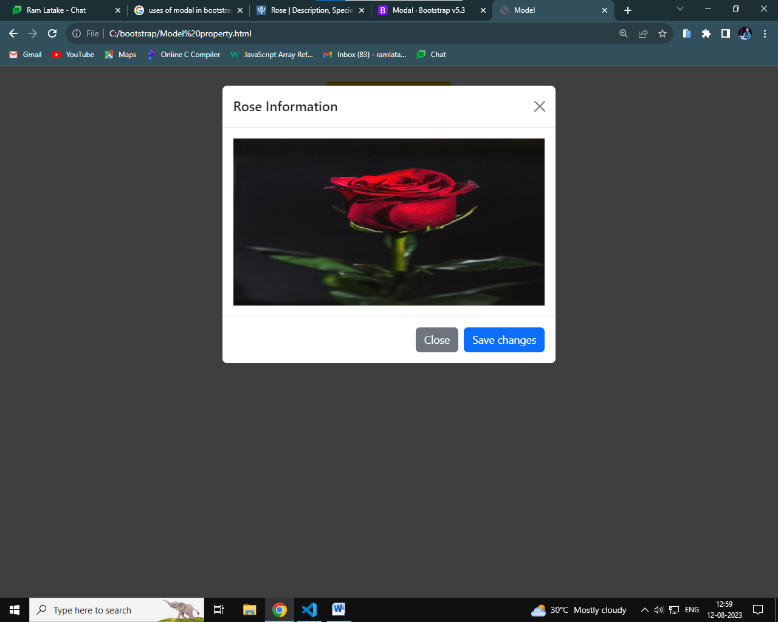

* **What is navbar ?**

 a navigation bar can extend or collapse, depending on the screen size.

* **uses :**

Navbar navigation links build on our . nav options with their own modifier class and require the use of toggler classes for proper responsive styling.

Example:-

**<!DOCTYPE html>**

**<html lang="en">**

**<head>**

**<meta charset="UTF-8">**

**<meta name="viewport" content="width=device-width, initial-scale=1.0">**

**<title>Navbar</title>**

**<link href="https://cdn.jsdelivr.net/npm/bootstrap@5.3.0/dist/css/bootstrap.min.css" rel="stylesheet" integrity="sha384-9ndCyUaIbzAi2FUVXJi0CjmCapSmO7SnpJef0486qhLnuZ2cdeRhO02iuK6FUUVM" crossorigin="anonymous">**

**<script src="https://cdn.jsdelivr.net/npm/bootstrap@5.3.0/dist/js/bootstrap.bundle.min.js" integrity="sha384-geWF76RCwLtnZ8qwWowPQNguL3RmwHVBC9FhGdlKrxdiJJigb/j/68SIy3Te4Bkz" crossorigin="anonymous"></script>**

**<script src="https://cdn.jsdelivr.net/npm/@popperjs/core@2.11.8/dist/umd/popper.min.js" integrity="sha384-I7E8VVD/ismYTF4hNIPjVp/Zjvgyol6VFvRkX/vR+Vc4jQkC+hVqc2pM8ODewa9r" crossorigin="anonymous"></script>**

**<script src="https://cdn.jsdelivr.net/npm/bootstrap@5.3.0/dist/js/bootstrap.min.js" integrity="sha384-fbbOQedDUMZZ5KreZpsbe1LCZPVmfTnH7ois6mU1QK+m14rQ1l2bGBq41eYeM/fS" crossorigin="anonymous"></script>**

**</head>**

**<body>**

**<nav class="navbar navbar-expand-lg navbar-light bg-info">**

**<a class="navbar-brand" href="#">Navbar</a>**

**<button class="navbar-toggler" type="button" data-toggle="collapse" data-target="#navbarNavAltMarkup" aria-controls="navbarNavAltMarkup" aria-expanded="false" aria-label="Toggle navigation">**

**<span class="navbar-toggler-icon"></span>**

**</button>**

**<div class="collapse navbar-collapse" id="navbarNavAltMarkup">**

**<div class="navbar-nav">**

**<a class="nav-item nav-link active" href="#">Home <span class="sr-only">(current)</span></a>**

**<a class="nav-item nav-link" href="#">Features</a>**

**<a class="nav-item nav-link" href="#">Pricing</a>**

**<a class="nav-item nav-link disabled" href="#">Disabled</a>**

**</div>**

**</div>**

**</nav>**

**</body>**

**</html>**

Output:-

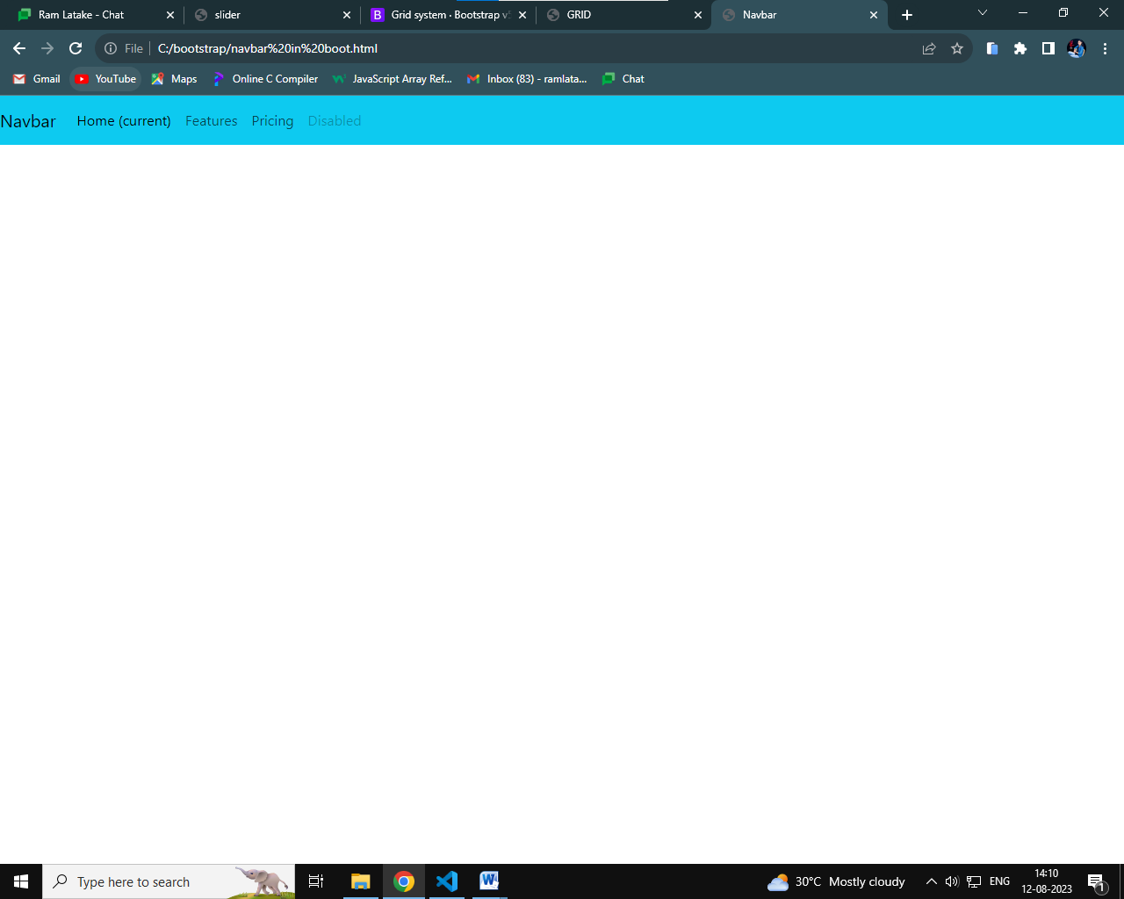

* **What is slider/carousoe?**

A slideshow component for cycling through elements images or slides of text like a carousel.

**uses:-**

1. Add image elements inside the parent div element. ...
2. Wrap each image in a div element. ...
3. Wrap all these inner divs in another div element. ...
4. Add controls with ARIA attributes.
5. Create a parent div element with an id and class attribute. ...

**Example:-**

<!DOCTYPE html>

<html lang="en">

<head>

    <meta charset="UTF-8">

    <meta name="viewport" content="width=device-width, initial-scale=1.0">

    <title>slider</title>

    <link href="https://cdn.jsdelivr.net/npm/bootstrap@5.3.0/dist/css/bootstrap.min.css" rel="stylesheet" integrity="sha384-9ndCyUaIbzAi2FUVXJi0CjmCapSmO7SnpJef0486qhLnuZ2cdeRhO02iuK6FUUVM" crossorigin="anonymous">

    <script src="https://cdn.jsdelivr.net/npm/bootstrap@5.3.0/dist/js/bootstrap.bundle.min.js" integrity="sha384-geWF76RCwLtnZ8qwWowPQNguL3RmwHVBC9FhGdlKrxdiJJigb/j/68SIy3Te4Bkz" crossorigin="anonymous"></script>

    <script src="https://cdn.jsdelivr.net/npm/@popperjs/core@2.11.8/dist/umd/popper.min.js" integrity="sha384-I7E8VVD/ismYTF4hNIPjVp/Zjvgyol6VFvRkX/vR+Vc4jQkC+hVqc2pM8ODewa9r" crossorigin="anonymous"></script>

    <script src="https://cdn.jsdelivr.net/npm/bootstrap@5.3.0/dist/js/bootstrap.min.js" integrity="sha384-fbbOQedDUMZZ5KreZpsbe1LCZPVmfTnH7ois6mU1QK+m14rQ1l2bGBq41eYeM/fS" crossorigin="anonymous"></script>

    <style>

        img{

            width: 100%;

            height: 400px;

        }

    </style>

</head>

<body>

      <div id="carouselExampleInterval" class="carousel slide" data-bs-ride="carousel">

        <div class="carousel-inner">

          <div class="carousel-item active" data-bs-interval="10000">

            <img src="https://cdn.pixabay.com/photo/2017/05/08/13/15/spring-bird-2295434_1280.jpg" class="d-block w-100" alt="...">

          </div>

          <div class="carousel-item" data-bs-interval="2000">

            <img src="https://cdn.pixabay.com/photo/2017/05/08/13/15/bird-2295431_1280.jpg" class="d-block w-100" alt="...">

          </div>

          <div class="carousel-item">

            <img src="https://cdn.pixabay.com/photo/2015/11/16/16/28/bird-1045954_1280.jpg" class="d-block w-100" alt="...">

          </div>

        </div>

        <button class="carousel-control-prev" type="button" data-bs-target="#carouselExampleInterval" data-bs-slide="prev">

          <span class="carousel-control-prev-icon" aria-hidden="true"></span>

          <span class="visually-hidden">Previous</span>

        </button>

        <button class="carousel-control-next" type="button" data-bs-target="#carouselExampleInterval" data-bs-slide="next">

          <span class="carousel-control-next-icon" aria-hidden="true"></span>

          <span class="visually-hidden">Next</span>

        </button>

      </div>

</body>

</html>

**output:-**

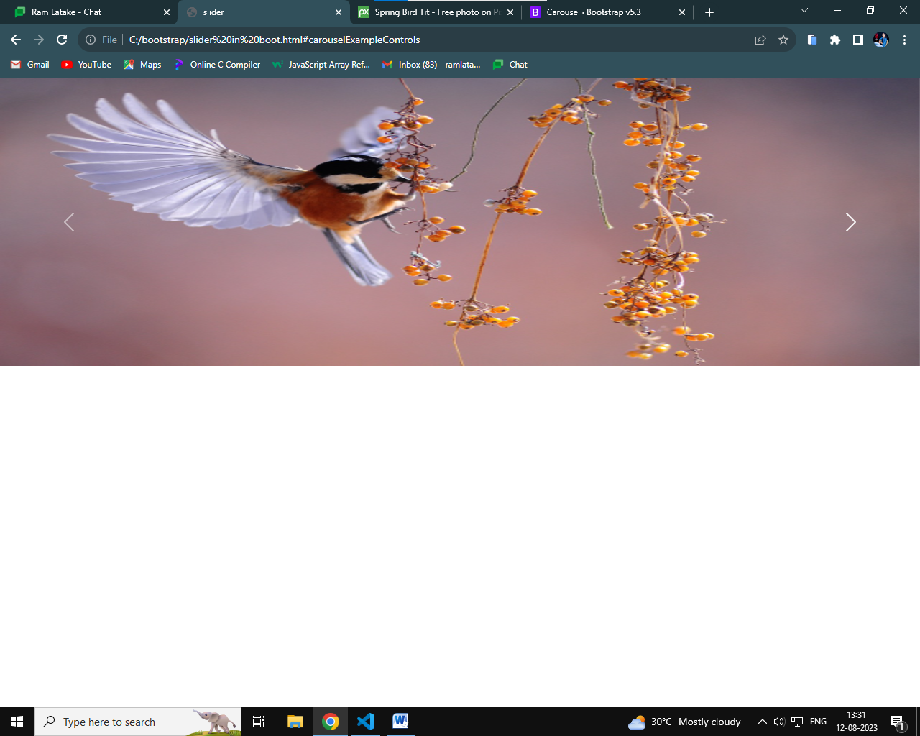

* **What is containers ?**

Containers are a fundamental building block of Bootstrap that contain, pad, and align your content within a given device or viewport.

**uses:-**

used to contain, pad, and (sometimes) center the content within them.

* **What is grid?**

Bootstrap's grid system uses a series of containers, rows, and columns to layout and align content.

**use:-**

The grid system helps create columns with the required size using the "col-size" class for a single column in a row.

**Exmaple:-**

**<!DOCTYPE html>**

**<html lang="en">**

**<head>**

**<meta charset="UTF-8">**

**<meta name="viewport" content="width=device-width, initial-scale=1.0">**

**<title>GRID</title>**

**<link href="https://cdn.jsdelivr.net/npm/bootstrap@5.3.0/dist/css/bootstrap.min.css" rel="stylesheet" integrity="sha384-9ndCyUaIbzAi2FUVXJi0CjmCapSmO7SnpJef0486qhLnuZ2cdeRhO02iuK6FUUVM" crossorigin="anonymous">**

**<script src="https://cdn.jsdelivr.net/npm/bootstrap@5.3.0/dist/js/bootstrap.bundle.min.js" integrity="sha384-geWF76RCwLtnZ8qwWowPQNguL3RmwHVBC9FhGdlKrxdiJJigb/j/68SIy3Te4Bkz" crossorigin="anonymous"></script>**

**<script src="https://cdn.jsdelivr.net/npm/@popperjs/core@2.11.8/dist/umd/popper.min.js" integrity="sha384-I7E8VVD/ismYTF4hNIPjVp/Zjvgyol6VFvRkX/vR+Vc4jQkC+hVqc2pM8ODewa9r" crossorigin="anonymous"></script>**

**<script src="https://cdn.jsdelivr.net/npm/bootstrap@5.3.0/dist/js/bootstrap.min.js" integrity="sha384-fbbOQedDUMZZ5KreZpsbe1LCZPVmfTnH7ois6mU1QK+m14rQ1l2bGBq41eYeM/fS" crossorigin="anonymous"></script>**

**<style>**

**div,.row{**

**border: 1px solid black;**

**}**

**</style>**

**</head>**

**<body>**

**<div class="container text-center">**

**<!-- Stack the columns on mobile by making one full-width and the other half-width -->**

**<div class="row">**

**<div class="col-md-8">.col-md-8</div>**

**<div class="col-6 col-md-4">.col-6 .col-md-4</div>**

**</div>**

**<!-- Columns start at 50% wide on mobile and bump up to 33.3% wide on desktop -->**

**<div class="row">**

**<div class="col-6 col-md-4">.col-6 .col-md-4</div>**

**<div class="col-6 col-md-4">.col-6 .col-md-4</div>**

**<div class="col-6 col-md-4">.col-6 .col-md-4</div>**

**</div>**

**<!-- Columns are always 50% wide, on mobile and desktop -->**

**<div class="row">**

**<div class="col-6">.col-6</div>**

**<div class="col-6">.col-6</div>**

**</div>**

**</div>**

**</body>**

**</html>**

output:-

